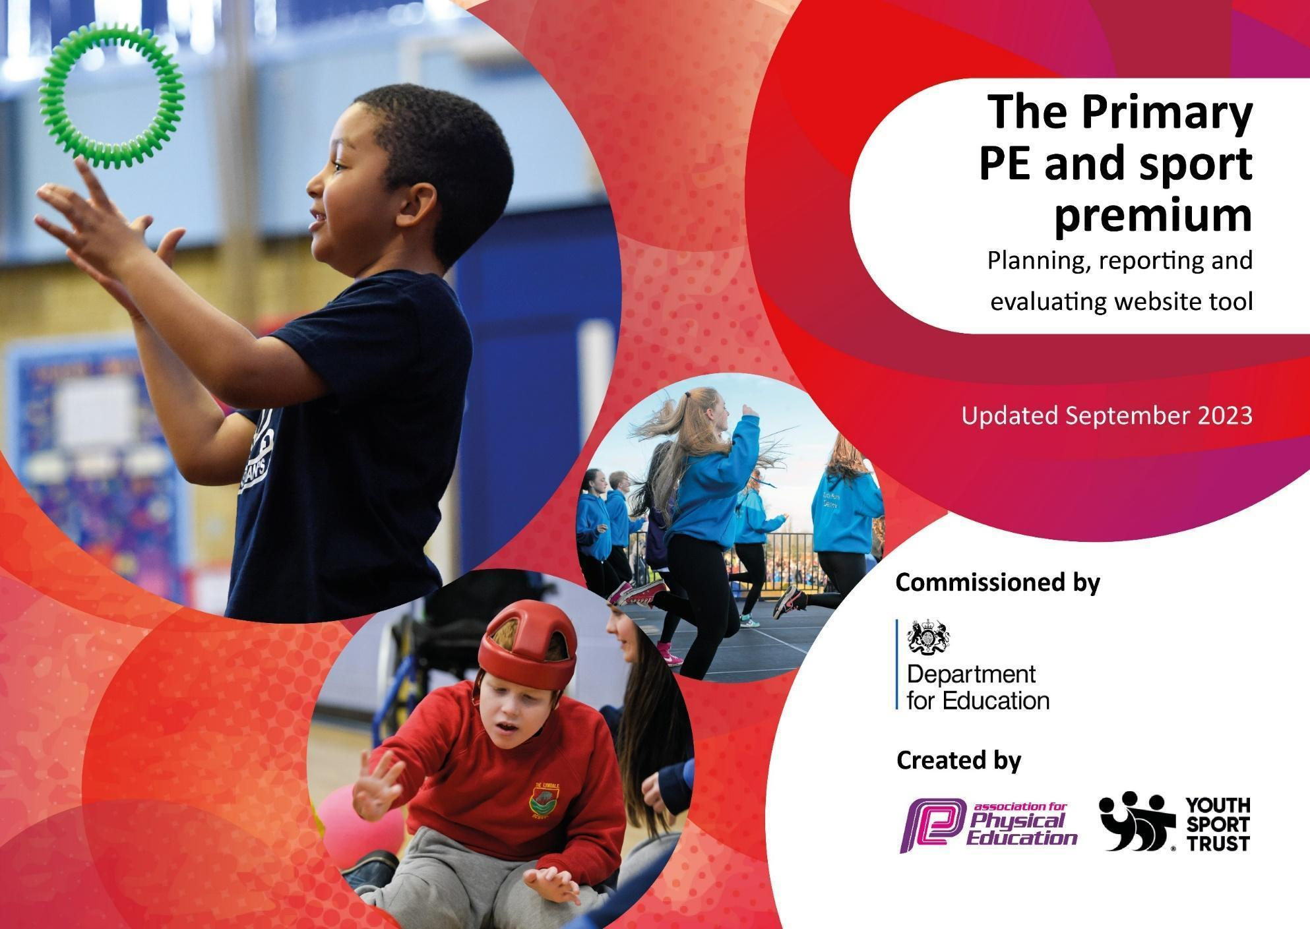



Key priorities and Planning 2025/2026 Crane Park Primary School 2025/26
This planning template will allow schools to accurately plan their spending.

Action – what are you planning to do | Digital Reporting Tool sub category | Key Indicator 1  Increased confidence, knowledge and skills of all staff in teaching PE and sport  What Impact are you expecting? (Include evidence) | Actual Impact and how sustainability will be achieved (include evidence) | Cost
CPD for Subject Leaders  Subject Leaders to attend borough HEP CPD events, Subject Leader Forums and annual PE conference.  Sport Impact to support Subject Lead in their role:  Support with Action Planning, curriculum planning and reviewing  Support with Platinum Games Mark Application  Keep up to date with latest CPD opportunities and resources.  Attendance at HEP training (Hounslow Education Partnership) | CPD- Conference- External Training Course  CPD-Internal Learning and development | - The subject leader is supported in their own CPD and development.  - Teachers feel supported by the subject leader.  - Subject lead will be supported in how to complete application. This will mean the school gets the best chance of achieving Platinum  - RD will be kept up to date with relevant news about the changes for next year when SSPs return | - We intend to continue to work with Sport Impact in the future to maintain opportunities for CPD  - RD has been given training throughout the year that makes sure she is up to date with current trends and the ever-changing landscape within PE  - RD attended Little Sticks Golf course.  - RD attended HEP meetings over the year.  - The Platinum award lasts for 2 years so the process does not have to be repeated next year | £400 to Attend Sport Impact Conference etc
CPD for teachers  Teachers receive CPD and mentoring in their PE lessons from a specialist teacher.  CPD for TAs  Sport Impact to deliver training |  | - Teacher confidence improved for the primary generalist teacher.  - This has a positive impact on the quality of PE, the engagement of the pupils and the progress the children are making in their PE lessons.  - CPD for TAs to ensure the correct support is given in PE lessons to all students | - Teachers reported greater confidence in the surveys completed at the end of the Support given. | S.I costs -  £2,500.00
PE Planning Support  Ensure all staff have access to accessible and easy to follow planning and assessment to support their PE teaching. | (Internal School Based Activities- use of educational platforms. | Staff being able to navigate and use the appropriate PE planning resources confidently will ensure progression of skills across the year groups. | - We are committed to Getset4PE for the foreseeable future and will continue to use this planning portal | £500 for annual subscription to Getset4PE
Action – what are you planning to do | Digital Reporting Tool sub category | Key Indicator 2  Engagement of all pupils in regular physical activity  What Impact are you expecting? (Include evidence) | Actual Impact and how sustainability will be achieved (include evidence) | Cost linked to the action
Reception Intervention  Children identified that are behind peers in fine and gross motor skills  Sessions to include simple games, singing, movement and play. | (External Activities- External Coaching staff. | - The nursery pupils develop their fundamental movement skills, including locomotion, stability and object control (observations and photos/videos)  - The sessions develop the children confidence, listening skills and give them an opportunity to play together. | - Children to be identified in future years. S.I to work with a group in the academic year | Part of SI costs  (see above)  £1000.00
SMSA Training and Active Playground Support  Train up SMSAs to support an active playground.  Link up with Play Leader training. | (External Activities- External Coaching staff. | - SMSAs are more confident in facilitating an active play environment. | - Additional equipment supplied  - SMSA training to take place next year | £1,600.00
Teach Active Lessons |  | - More pupils achieving 60 active minutes a day and participating in more physical activity through Teach Active maths lessons. | Teachers were given logins to the Teach Active website with Teach Active lessons being used regularly to consolidate children’s learning whilst increasing their physical activity levels. | Teach Active Subscription £630
Action – what are you planning to do | Digital Reporting Tool sub category | Key Indicator 3  The profile of PE and sport is raised across the school as a tool for whole school improvement  What Impact are you expecting? (Include evidence) | Actual Impact and how sustainability will be achieved (include evidence) | Cost linked to the action
Leadership  Train up Year 5 Leaders.  Sport Impact to deliver Play Leader training to the whole of Year 5  Leaders to run different events throughout the year | External Activities- External Coaching staff. | - Pupils develop key leadership skills- Confidence, Communication, organisation, cooperation.  - Play leaders support an KS1 active play zone  - Sports Leaders become part of the PE& Sport workforce. | - All students have access to a leadership course and those that want to continue get the opportunity to.  - These leadership skills can be used across the school in other areas. | Part payment for S.I  £1000.00
Pupil Voice  Send out Koboca pupil voice survey. | No cost (Part of Sport Impact SLA) |  | Analyse data in September | No cost (Part of Sport Impact SLA)
Action – what are you planning to do | Digital Reporting Tool sub category | Key Indicator 4  Broader experience of a range of sports and activities offered to all pupils  What Impact are you expecting? (Include evidence) | Actual Impact and how sustainability will be achieved (include evidence) | Cost linked to the action
Swimming  Look at the use of extra top up lessons to support those who don’t meet the national criteria set out at the end of year 6 | Internal School Based Activity- Top up Swimming. | - Increase the % of pupils in KS2 that can swim competently, confidently and proficiently over a distance of at least 25 metres? | Target to be carried over into next academic year | £1,140.00 – spent overall for the year
Employment of a Sports Coach  PE specific interventions for targeted pupils in curricular and extra-curricular.  Additional coached Lunchtime activity sessions  Sensory Circuits.  Targeted swimming support | External Activities- External Coaching staff. | - Lunchtime sessions with coaches to support pupils with competition preparation, increasing active opportunities for all younger people and providing clubs based on the needs of the pupils.  - Additional term to enhance swimming strategies. | - Regular weekly and daily sessions with the coaches from BFFCST  - Regular weekly netballs session from NBNC Flames | BFFCST Clubs: £4,463.00  Netball Club: £140.00 per week – 2 hours of Netball.  £875.00  £385.00  Swimming  £1,140.00
Extra-Curricular Clubs  Use feedback from pupil voice surveys to ensure extra-curricular club provision reflects the needs of the pupils.  Reach out to local organisations to support running of clubs if needed. | Internal School Based- School based extra-curricular opportunities. | - Provision of breakfast clubs, lunchtime clubs and after school clubs to boost the range of sports and activities on offer to pupils | - Regular after school clubs provided by BFFCST  - Active morning club led by Sport Impact  - Weekly lunch time netball club led by NBNC Flames. | BFFCST Clubs: (see above)  Active Club: Part payment for SI  Netball Club: see above
PE Equipment  Subject leader to carry out regular PE equipment audits.  Consult staff over equipment requirements. Check ALL curriculum activities can be resourced.  Shade Sails | (Internal School Based- Equipment and Resource. | - New equipment allows pupils to experience a broader range of sports and activities.  - Adapted equipment allows ALL pupils to access PE.  - Areas to allow children to be taught in the shade on the playground – sun safety. | - Equipment audit completed and new equipment for clubs, sports leaders, intra-school competitions and SEN sessions purchased. | £5000
Action – what are you planning to do | Digital Reporting Tool sub category | Key Indicator 5  Increased participation in competitive sport  What Impact are you expecting? (Include evidence) | Actual Impact and how sustainability will be achieved (include evidence) | Cost linked to the action
Borough Competitions  Increase the number of pupils attending competitions by entering the Inspire, Develop, Complete.  Organise training sessions before competitions to ensure pupils are adequately prepared. | Sport Impact – External- Activities Organised by School Games organiser network.  External- Other Inter-school sports competitions. | - More pupils get to experience inclusive competitions that are appropriate for their age and stage.  - Pupils receive adequate training before competitions to ensure they are prepared.  - If pupils have an enjoyable experience at the competitions, they are more likely to engage in the future. | - 29 Competitions attended in all categories (Inspire, develop, complete) by a broad range of pupils from KS1 – KS2.  - Training provided for pupils by BFCCST Coaches at lunchtimes and SI during specific sessions. | - BFCCST Coaches at lunchtimes (Part cost)  - £971.00  - SI part costs - £500.00
Sports Day  Plan a Sports Day event for KS1 and KS2  Provide Leaders for KS1 Sports Day if needed  Focus on the outdoor classroom/ swimming and House competitions | External- Other Inter-school sports competitions. | Sports Day enables pupils to come together as a school community and experience a range of activities.  Sports Day provides an opportunity to expose pupils to inclusive competition. | - Whole school event inclusive of SEN unit, EYFS, KS1 and KS2 where children participated in a carousel of activities.  - Y6 Leaders supported with the EYFS/KS1 event. | - SI part costs
 |  |  | Spending against each key indicator | 1 - £3000.00  2 - £3200.00  3 - £1000.00  4 - £11,863.00  5 - £1,471.00
 |  |  | Total Allocation  Total Reported Spend | £19,610  £20,534

Swimming Data
Meeting National Curriculum requirements for swimming and water safety.
Priority should always be given to ensuring that pupils can perform safe self-rescue even if they do not fully meet the first two requirements of the National Curriculum programme of study

Question | Stats: | Further context  Relative to local challenges
What percentage of your current Year 6 cohort can swim competently, confidently and proficiently over a distance of at least 25 metres? | 41% | Our pupils receive their statutory lessons for 15 weeks in Year 4. For some of our families and children, this can be the first and only time our children experience learning to swim.
What percentage of your current Year 6 cohort can use a range of strokes effectively [for example, front crawl, backstroke, and breaststroke]? | 41% | As many of our pupils are unable to swim when they first start lessons, grasping the basics and developing confidence to stay afloat in the water becomes the primary focus for their lessons. Those who are competent or progress quickly, will master the range of strokes.

What percentage of your current Year 6 cohort are able to perform safe self-rescue in different water-based situations? | 37% | As above, as many of our pupils are unable to swim when they first start lessons, the focus is around grasping the basics and developing confidence. Although many understand how to float in the water, not many are confident to complete this or know what to do in an emergency as lessons did not focus on this.
If your schools swimming data is below national expectation, you can choose to use the Primary PE and sport premium to provide additional top-up sessions for those pupils that did not meet National Curriculum  requirements after the completion of core lessons. Have you done this? | Yes | Need to investigate how to go about this, the cost and the logistics of how we operate the additional lessons.
Have you provided CPD to improve the knowledge and confidence of staff to be able to teach swimming and water safety? | No | Swimming is taught externally by external coaches. Our class teachers do not teach swimming.

Signed off by:

Head Teacher: | Alison Small
Subject Leader or the individual responsible for the Primary PE and sport premium: | Rebecca Day
Governor:
Date: | July 2026

